Engagement feedback report

Community Land revocation proposal

Thames Drive Reynella

July 2025

Introduction
The City of Onkaparinga is committed to ensuring our land and assets best serve our community. When a property no longer meets current or future needs, we consider selling it, so we can reinvest the proceeds in ways that benefit residents. This approach, often called an “asset optimisation strategy,” also supports our financial sustainability and forms part of our Long-Term Financial Plan.
Under South Australian law, land classified as “community land” must go through a formal revocation process before it can be sold.
On 18 March 2025, Council approved the commencement of this process for Allotment (Reserve) 461 Thames Drive, Reynella.

Communication and engagement purpose
The purpose of engagement was to understand whether the community is supportive of the proposal to revoke the community land classification to enable the sale of Allotment (Reserve) 461 Thames Drive, Reynella, identify which capital works projects they would like to see prioritised in the sale proceeds, and comply with legislative requirements.

Communication and engagement activities
The activities undertaken to drive engagement and participation were:
- Elected member email.
- On-site signage.
- Public notice in the Advertiser.
- Dedicated Your Say Onkaparinga webpage with project information and feedback tools.
- 1,735 registered members of Your Say Onkaparinga received an email on the proposed revocation
- 78 Letters sent to residents and absent owners identified in the below map.
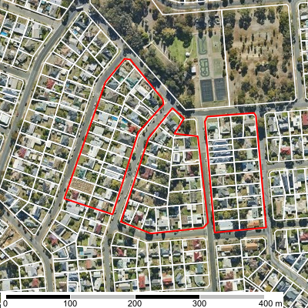
Summary of Community Engagement outcomes
Engagement was open from 7 July 2025 to 28 July 2025.
Based on previous land revocation engagements, projects receiving over 100 contributions are considered to have ‘high’ interest, 50–99 ‘medium’, and fewer than 50 ‘low’. The level of interest for the proposed land revocation at Thames Drive is considered low, with a total of 40 contributions received:
- 13 via the online survey
  - One (1) participant submitted an address that doesn’t meet stated requirements and has not been counted
- 25 via the quick poll
- 2 written responses via email and letter
In total 183 people visited the Your Say Onkaparinga page resulting in 39 valid contributions.
After collating all feedback received, the overall results are shown below:

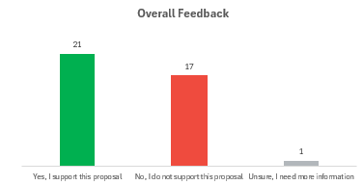

Online feedback
Via the Your Say Onkaparinga webpage, the community was able to provide feedback via an online survey, or an online quick poll. The online quick poll was designed to capture feedback from participants who didn’t feel the need to complete the survey but were happy to provide a quick ‘one click’ response.
Online Survey
A total of thirteen (13) submissions were received via the online survey. One (1) participant submitted feedback but provided a PO Box address, which does not meet the stated requirements on the YourSay page. As a result, their vote has not been counted. Their comments however have been included for reference in Appendix A.
Participants were provided with information that if the revocation is approved and sale of the land successful, a contribution of the proceeds would prioritise a capital works project to benefit the local community.
Six (6) project types were provided for the community to place these in priority from most important to least important. Below are the results showing the communities priorities:

Project Type | Average Rating
Improvements to public spaces such as a reserve upgrade | 1.17
Environmental initiatives such as erosion control | 1.33
Footpath, foot bridge or multi-use trail upgrade | 1.75
Environmental initiatives such as erosion control | 1.33
Traffic management | 2.42
Community building upgrade | 2.33
Road upgrade | 2.42

Participants were then asked whether they supported the proposal, which resulted in the below results.
To better understand how nearby residents feel about the proposed revocation of the subject parcel, we’ve grouped the feedback into two (2) categories based on how far they live from the land in question.

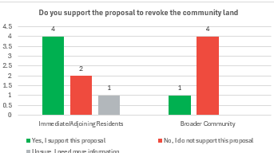￼

All participants were able to provide written comments online. These comments are summarised below. Verbatim survey comments can be found at Appendix A
Those in support
Of the five (5) participants in support of the revocation that responded only two (2) left a comment. The summary of their comments are as follows:
- Support for the sale of the land, encouraging Council to use the for a rate reimbursement in nearby suburbs.
- A general endorsement of the initiative.
Those unsure
Only one (1) participant expressed uncertainty about the revocation and raised a concern that some existing community groups may need facilities that could be accommodated at this site.
Those not in support
A total of seven (7) participants submitted feedback in opposition to the revocation. Of these, six (6) met the submission requirements and have been counted. A summary of the key concerns and themes raised by all seven (7) participants are summarised below:
- Concern about the ongoing loss of public open space across suburbs more generally, particularly in the context of increasing housing density.
- Emphasis on the broader ecological value of small open spaces, noting their role in supporting birdlife and biodiversity in residential areas where private gardens and mature trees are being lost due to infill development.
- Encouragement for Council to consider community use options for small reserves across the city rather than selling them.
- Concern about the impact that revoking this specific parcel would have on the local character of Old Reynella, suggesting the loss of green space would detract from the suburb’s visual and environmental appeal.
- Concern about the future of a significant tree on the site, with requests to protect and retain it should the revocation proceed.
- Concerns raised about broader Council practices of asset disposal, perceived financial mismanagement, and the risk of losing valued community assets without clear long-term strategy.
- Criticism that the proposal conflicts with Council’s own Environment and Sustainability Policy, which identifies native vegetation and open space as valuable community assets.
Quick poll
A total of twenty-five (25) participants responded to the quick poll. It is important to note that the poll did not allow respondents to provide reasons for their views, nor is it known whether the participants are local ratepayers or residents of the area near the land parcel. The responses are summarised below:
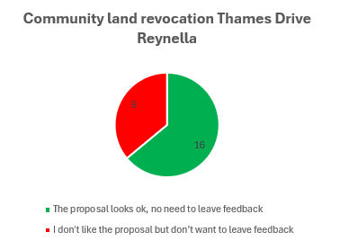
Other feedback
Two (2) written submission were received with both in opposition to the proposal (refer to Appendix B). It is important to note that both residents are adjoining landowners to the subject parcel.
Summary
In total 183 people visited the Your Say Onkaparinga page resulting in 39 valid contributions.
After collating all feedback received, the overall results are shown below:

Evaluation
The engagement met its objectives and purpose by:
- Providing clear, easy to read information on the Your Say page to ensure stakeholders, residents, and the community have a good understanding on what they can influence along with information on the revocation process and where the proceeds of sale will be going.
- Providing inclusive ways in which to contact us and provide information other than online.
- Complying with legislative requirements by providing the Council Reports, Minutes and Sections 194 report on the Your Say page.
Throughout the engagement, there were:
- 183 visitors to the Your Say page.
- A total of 39 valid contributions received online and via email.
- Five (5) online participants went on to provide feedback about our engagement process:
  - 80% told us it was easy to provide feedback
  - 80% told us information was clear and easy to understand
  - 60% told us there was enough time to find out more information and provide feedback

Sign-off
Officer who prepared the document
Name: | Tristan Mellet
Position title: | Property Officer Transactions
Reviewed by
Name: | Paula Bugden
Position title: | Community Engagement Advisor
Date: | 30/7/2025
Reviewed by
Name: | Rochelle Redmond
Position title: | Asset Optimisation Specialist
Date: | 30/07/2025
Approved by
Name: | Steven wachtel
Position title: | Manager Organisational Excellence
Date:

Appendix A: Verbatim Your Say Survey Comments
Yes, I support this proposal | Proximity to Revocation
I would rather see the proceeds from the sale of this block and the one on Brodie Road go to council rate reduction or reimbursement of every ratepayer in the surrounding suburbs of Reynella, Morphett Vale,Hackham and Happy Valley. | Immediate/Adjoining Residents
Great initiative, City of Onkaparinga | Immediate/Adjoining Residents

No, I do not support this proposal | Proximity to Revocation
Our open spaces must be protected and valued. Council should refer to their own Environment and Sustainability Policy which clearly states; "we value our native vegetation for the important roles it plays in the landscape. Our open spaces are a place for recreation and relaxation ".  How the Council can contemplate selling these spaces, so vital for wildlife and human well-being alike, is an insult and a disservice to their ratepayers, who deserve their consideration.  Once these important spaces are gone, there is no turning back. | Broader Community
It's important to have these small natural spaces in residential areas. They will become increasingly important as more existing houses in this area are demolished and replaced with multiple dwellings. It is refreshing to see these spaces when walking the neighbourhood. There is a lot of birdlife in the area. With the removal of existing gardens and tress to make way for houses with little or no space for trees, again, these small havens for wildlife and birds are important. | Immediate/Adjoining Residents
Please try to think of ways the community can use this. What about a family friendly skate park with a playground, BBQs & a toilet. I am told the Christies downs one is good except for drug dealers hanging around there. Maybe police could do drive byes to deter people from doing illegal things. We need to have places kids can go, with no screens. To learn how to socialise and treat others. They need to enjoy themselves outdoors | Broader Community
We need to retain open spaces, for the community and the future. | Broader Community
I do not support this proposal as I have concerns about how the land will be used and what will happen to the significant tree on the site. We need more green spaces, not less. | Broader Community
This appears to be in line with councils ongoing policy of selling off land to balance its out-of-control expense budget. I recommend instead council lower their wildly out of control wages expenses and leave community land for the community. Alternatively, if they are not capable of controlling their budget I recommend handing the entirety of their community land back to the state government for maintenance and disbanding Onkaparinga Council, they exist to maintain community facilities and if they cannot do so without selling off the community property they are employed to maintain there is no value to their continued exitance and they are a liability to the community. | PO Box Provided
Green space is disappearing everywhere in the name of progress. Not for residents in the vicinity.  It will detract from Old Reynella environment and ambience. | Immediate/Adjoining Residents

Unsure, I need more information | Proximity to Revocation
Puddle jumpers and The Men's Shed need a location. Build a community SHED for them both here! | Immediate/Adjoining Residents

Appendix B: Feedback via Email

