Engagement feedback report

Community Land revocation proposal

Brodie Road Huntfield Heights

July 2025

Introduction
The City of Onkaparinga is committed to ensuring our land and assets best serve our community. When a property no longer meets current or future needs, we consider selling it, so we can reinvest the proceeds in ways that benefit residents. This approach, often called an “asset optimisation strategy,” also supports our financial sustainability and forms part of our Long-Term Financial Plan.
Under South Australian law, land classified as “community land” must go through a formal revocation process before it can be sold.
On 18 March 2025, Council approved the commencement of this process for Allotment (Reserve) 221 Birchenough Road, Huntfield Heights (otherwise known as Reserve Brodie Road).

Communication and engagement purpose
The purpose of engagement was to understand whether the community is supportive of the proposal to revoke the community land classification to enable the sale of Allotment (Reserve) 221 Birchenough Road, Huntfield Heights (otherwise known as Reserve Brodie Road), identify which capital works projects they would like to see prioritised in the sale proceeds, and comply with legislative requirements.

Communication and engagement activities
The activities undertaken to drive engagement and participation were:
- Elected member email.
- On-site signage.
- Public notice in the Advertiser.
- Dedicated Your Say Onkaparinga webpage with project information and feedback tools.
- 1,714 registered members of Your Say Onkaparinga received an email on the proposed revocation
- 58 Letters sent to residents and absent owners identified in the below map.
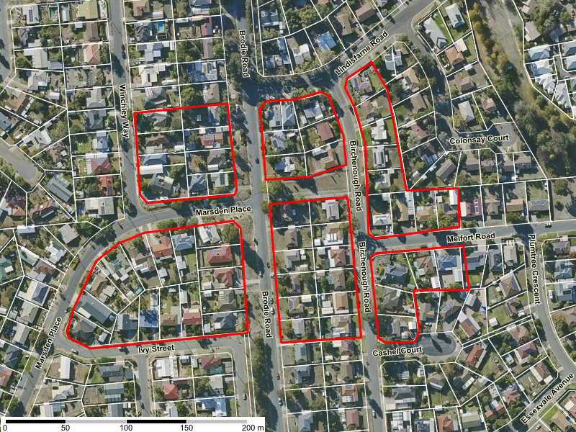

Summary of Community Engagement outcomes
Engagement was open from 7 July 2025 to 28 July 2025.
Based on previous land revocation engagements, projects receiving over 100 contributions are considered to have ‘high’ interest, 50–99 ‘medium’, and fewer than 50 ‘low’. The level of interest for the proposed land revocation at Brodie Road is considered low, with a total of 34 contributions received:
- 14 via the online survey
  - One (1) participant submitted an address that doesn’t meet stated requirements and has not been counted.
- 17 via the quick poll
- 3 written responses via email or letter

In total 156 people visited the Your Say Onkaparinga page resulting in 33 valid contributions.
After collating all feedback received, the overall results are shown below:

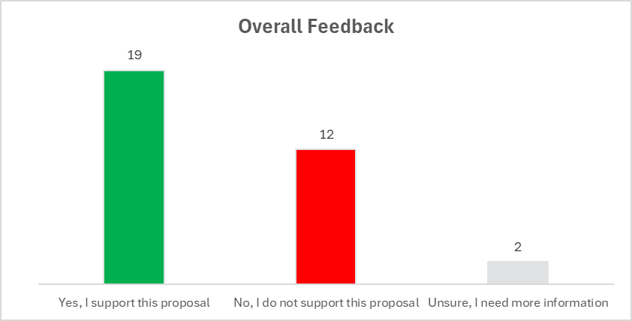

Online feedback
Via the Your Say Onkaparinga webpage, the community was able to provide feedback via an online survey, or an online quick poll. The online quick poll was designed to capture feedback from participants who didn’t feel the need to complete the survey but were happy to provide a quick ‘one click’ response.
Online Survey
A total of 14 submissions were received via the online survey. One (1) participant submitted feedback but provided a PO Box address, which does not meet the stated requirements on the YourSay page. As a result, their vote has not been counted. Their comments however have been included for reference in Appendix A.
Participants were provided with information that if the revocation is approved and sale of the land successful, a contribution of the proceeds would prioritise a capital works project to benefit the local community.
Six (6) project types were provided for the community to place these in priority from most important to least important. Below are the results showing the communities priorities:

Project Type | Average Rating
Improvements to public spaces such as a reserve upgrade | 1.46
Footpath, foot bridge or multi-use trail upgrade | 1.85
Environmental initiatives such as erosion control | 2.00
Traffic management | 3.15
Community building upgrade | 2.62
Road upgrade | 2.23

Participants were then asked whether they supported the proposal, which resulted in the below results.
To better understand how nearby residents feel about the proposed revocation of the subject parcel, we’ve grouped the feedback into two (2) categories based on how far they live from the land in question.

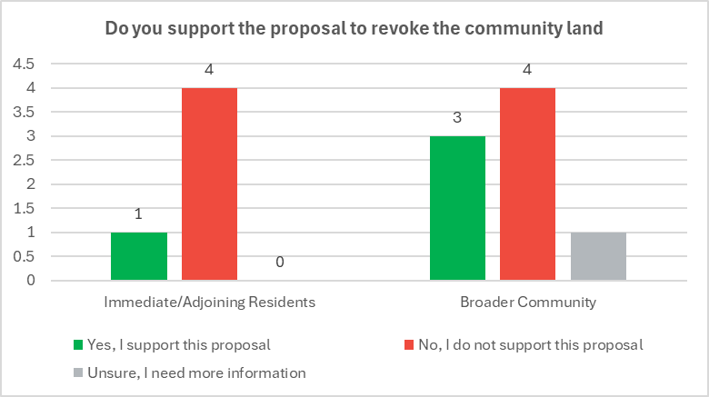

All participants were able to provide written comments online. These comments are summarised below. Verbatim survey comments can be found at Appendix A

Those in support
Of the four (4) participants in support of the revocation that responded all four (4) left a comment. The summary of their comments are as follows:

- The land is considered vacant, underutilised, or acting as a dumping ground.
- Strong support for using the land to address housing demand in the area, with suggestions that it could help accommodate growing populations.
- Recommendation that proceeds from the land sale be used for broader community benefit, including reimbursing ratepayers.
- General sentiment that the disposal is a positive initiative and a better long-term use of the land.
Those unsure
Only one (1) participant was unsure of the revocation and noted they do not live in the immediate area but expressed concern that the land appears to be the only green space nearby. They recommended that all local residents be notified and given an opportunity to provide feedback.
Those not in support
A total of ten (10) participants submitted feedback in opposition to the revocation. Of these, nine (9) met the submission requirements and have been counted. A summary of the key concerns and themes raised by all ten (10) participants are summarised below:
- Opposition to the sale of public land, with concerns that the continued disposal of community spaces undermines long-term public benefit for short-term financial gain.
- Frequent and valued use of the land as a pedestrian link, particularly by school children and local families.
- Belief that community landforms part of the suburb’s original planning intent and should be protected to preserve local amenity, green space, and property value.
- Suggestions to include a community garden, shaded seating, fitness or play equipment, and space for social gatherings.
- Comments that housing needs could be addressed through other underutilised private land or existing subdivisions.
- Concerns raised about broader Council practices of asset disposal, perceived financial mismanagement, and the risk of losing valued community assets without clear long-term strategy.
- Noted concern about the potential loss of trees and environmental features on the site if sold.

Quick poll
A total of seventeen (17) participants responded to the quick poll. It is important to note that the poll did not allow respondents to provide reasons for their views, nor is it known whether the participants are local ratepayers or residents of the area near the land parcel. The responses are summarised below:
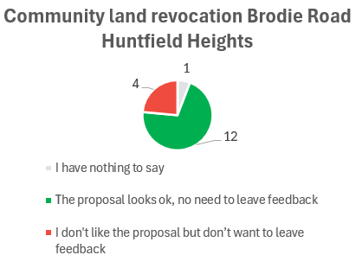

Other feedback
Three (3) written submission were received via email with all three (3) supporting the proposal (refer to Appendix B). It is important to note that all three residents are within 150m from the subject parcel. Key concerns and themes included:
- General support for the sale of the land was expressed in all submissions, with the understanding that the proceeds could benefit Council or the wider community.
- All three respondents requested that the existing pedestrian walkway between Brodie Road and Birchenough Road be retained, noting that it is frequently used by residents — particularly for access to public transport and local amenities.
- Some concern was expressed regarding potential development outcomes, with specific requests to preserve the large gum tree near Brodie Road and ensure that any future dwellings reflect the existing neighbourhood character.

Evaluation
The engagement met its objectives and purpose by:
- Providing clear, easy to read information on the Your Say page to ensure stakeholders, residents, and the community have a good understanding on what they can influence along with information on the revocation process and where the proceeds of sale will be going.
- Providing inclusive ways in which to contact us and provide information other than online.
- Complying with legislative requirements by providing the Council Reports, Minutes and Sections 194 report on the Your Say page.
Throughout the engagement, there were:
- 156 visitors to the Your Say page.
- A total of 33 valid contributions received online and via email.
- Six (6) online participants went on to provide feedback about our engagement process:
  - 83% told us it was easy to provide feedback
  - 83% told us information was clear and easy to understand
  - 50% told us there was enough time to find out more information and provide feedback

Sign-off
Officer who prepared the document
Name: | Tristan Mellet
Position title: | Property Officer Transactions
Reviewed by
Name: | Paula Bugden
Position title: | Community Engagement Advisor
Date:
Reviewed by
Name: | Rochelle Redmond
Position title: | Asset Optimisation Specialist
Date:
Approved by
Name: | Steven wachtel
Position title: | Manager Organisational Excellence
Date:

Appendix A: Verbatim Your Say Survey Comments
Yes, I support this proposal | Proximity to Revocation
The land is vacant and not serving any purpose.  There is plenty of open land nearby for people to use…  I would really like to see each ratepayer reimbursed for their council rates with the proceeds of this land and the Thames Road parcel at Reynella. | Broader Community
We need the land for housing, and if this money can be used for other projects that is a good thing. | Broader Community
the land is not very use full as it is and some time it is just a dumpping ground ,also we need more houses | Immediate/Adjoining Residents
There is a lot of surplus land in our neighbourhood, which can make way for additional housing.  Great initiative, City of Onkaparinga | Broader Community

No, I do not support this proposal | Proximity to Revocation
I have lived here for 39 years i belive it should not be sold privately i feel it should go to SA housing for disability housing or social housing | Immediate/Adjoining Residents
The path is helpful for me and other people | Immediate/Adjoining Residents
My children use that path to walk to the bus stop on Brodie Road. They also use it to access Melsetter Road to visit their grandparents and their cousins. This path is very well used by other members of the public walking their children to school as well creating a more streamline walk to school rather than having to detour around the block. Having that path allows me to safety watch my children cross the road from my house. I would prefer the path stays in place. | Immediate/Adjoining Residents
I do not support this sale, there is still currently plenty of other opportunities to increase housing density in the area, with vacant private land and subdivisions.  The sale of public assets and the proceeds can only be done once, with those benefits give in a finite way. Selling down assets without replacing them with improved alternatives is a short sighted and short term salutation in general.  My children use this walkway space regularly without dog. The thoroughfare is important also for connecting pedestrian traffic.  I agree it could be better utilised. For example seating shelter, and or play or fitness equipment. | Immediate/Adjoining Residents

Instead of selling it, turn it into a useful space. A community garden, it can be fenced off and community pay for an area to grow whatever they like. Have a couple of people paid to help with upkeep. When the garden has been established and during the process, have time for everyone to sit around with a coffee and a biscuit to share ideas and information. I understand that there might be some issues to begin with but once the community are proud of the space they will protect it | Broader Community
We need to retain open spaces, for the community and the future. | Broader Community
People who bought properties around the community land would have done so on the understanding that, as community land, it should be untouchable. Original planning of suburbs includes a certain percentage of community land, which can provide habitat for wildlife as well as the open, green spaces necessary for human well-being. Most of the recent "your say" projects have been relinquishing of community land and if, they're all approved, the amenity of the suburbs in question is compromised and even the value of adjoining properties goes down. People who buy next to parks and open spaces do so for a reason! It seems like a cash grab, to the detriment of existing City of Onkaparinga residents and ratepayers. You might say that it's just one little park, but you're doing it over and over! Not acceptable! | Broader Community
I do not support this proposal as I have concerns about how the land will be used and what will happen to the significant tree on the site. We need more green spaces, not less. | Broader Community
This appears to be in line with councils ongoing policy of selling off land to balance its out of control expense budget. I recommend instead council lower their wildly out of control wages expenses and leave community land for the community. Alternatively, if they are not capable of controlling their budget I recommend handing the entirety of their community land back to the state government for maintenance and disbanding Onkaparinga Council, they exist to maintain community facilities and if they can not do so without selling off the community property they are employed to maintain there is no value to their continued exitance and they are a liability to the community.  This appears to be in line with councils ongoing policy of selling off land to balance its out of control expense budget. I recommend instead council lower their wildly out of control wages expenses and leave community land for the community. Alternatively, if they are not capable of controlling their budget I recommend handing the entirety of their community land back to the state government for maintenance and disbanding Onkaparinga Council, they exist to maintain community facilities and if they can not do so without selling off the community property they are employed to maintain there is no value to their continued exitance and they are a liability to the community. | Broader Community

Unsure, I need more information | Proximity to Revocation
I don't live in the area and it seems to be the only green space. nearby so all residents in the community should be notified and offered to have their say | Broader Community

Appendix B: Feedback via Email

